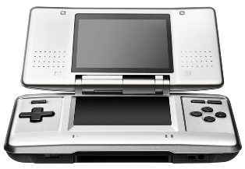
Nintendo's handheld system for 2004-2005 is the Nintendo DS, the first dual screen handheld gaming system.
Specs:
- Size (closed): 5.85" wide / 3.33" long / 1.13" tall
- Upper Screen: Backlit, 3-inch, semitransparent reflective TFT color LCD with 256x192 pixel resolution and .24 mm dot pitch
- Touch Screen: Same as upper screen, but with transparent analog touch screen
- Color: Capable of displaying 260,000 colors
- Wireless Communication: IEEE 802.11 and Nintendo's proprietary format; wireless range is 30 to 100 feet, depending on circumstances; multiple users can play multiplayer games using just one DS game card
- Controls: Touch screen, embedded microphone for voice recognition, A/B/X/Y face buttons, plus control pad, L/R shoulder buttons, Start and Select buttons
- Input/Output: Ports for both Nintendo DS game cards and Game Boy Advance Game Paks, terminals for stereo headphones and microphone
- Other Features: Embedded PictoChat software that allows up to 16 users to chat at once; embedded real-time clock; date, time and alarm; touch-screen calibration
- CPUs: One ARM9 and one ARM7
- Sound: Stereo speakers providing virtual surround sound, depending on the software
- Battery: Lithium ion battery delivering six to 10 hours of play on a four-hour charge, depending on use; power-saving sleep mode; AC adapter
- Languages: English, Japanese, Spanish, French, German, Italian
- Color: Silver and black

